SIMATS ENGINEERING
CO2 - ASSESSMENT TOOL 2
Scenario-Based Questions
COURSE NAME: Deep Learning | COURSE CODE: | MLA04
Faculty : Dr. Arul Raj A.M | Slot : D

COURSE OUTCOME COVERED
CO 2:Students will be able to apply supervised learning algorithms such as linear regression, classification models, decision trees, neural networks, support vector machines, and ensemble methods to solve real-world prediction and classification problems. They will gain the ability to select appropriate models, train them using datasets, and evaluate their performance. Students will also understand the strengths and limitations of different supervised learning approaches.(BTL-4)
Name of the Student | Uppu Sye Kumar
Reg. No | 192325121
GitHub Link | https://github.com/syekumar/MLA0405-Deep-Learning

CO Weightage : 15%
Assessment Tool Weightage: 40%
Duration: 90 minutes

Marks: 25
Code of Conduct:
I Uppu Sye Kumar/192325121(Name / Reg No) certify that this submission is my original work and that I have adhered to the guidelines specified for this assessment.
I understand that any violation of academic integrity rules will result in disciplinary action.
Signature of the student:U.syekumar Name of the student:Uppu Sye Kumar

Scenario-Based Questions
CO-AT2
QUESTIONS: 05 Total Marks:25

Unsupervised Training of Neural Networks, Auto Encoders
A hospital wants to identify abnormal ECG patterns from thousands of unlabeled records. Which deep learning technique from the syllabus would you recommend? Justify your choice and explain the workflow.
Answer
For identifying abnormal ECG patterns from thousands of unlabeled records, an Autoencoder is the most suitable deep learning technique.
An autoencoder is an unsupervised neural network that learns to reconstruct its input. It can learn the characteristics of normal ECG patterns and identify unusual ECGs using reconstruction error.
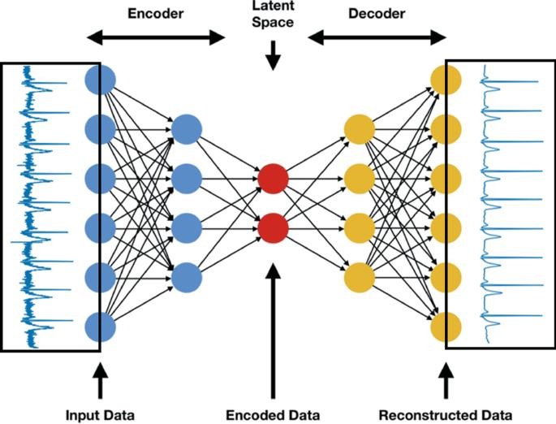
Figure 1: Autoencoder-based ECG Anomaly Detection Workflow
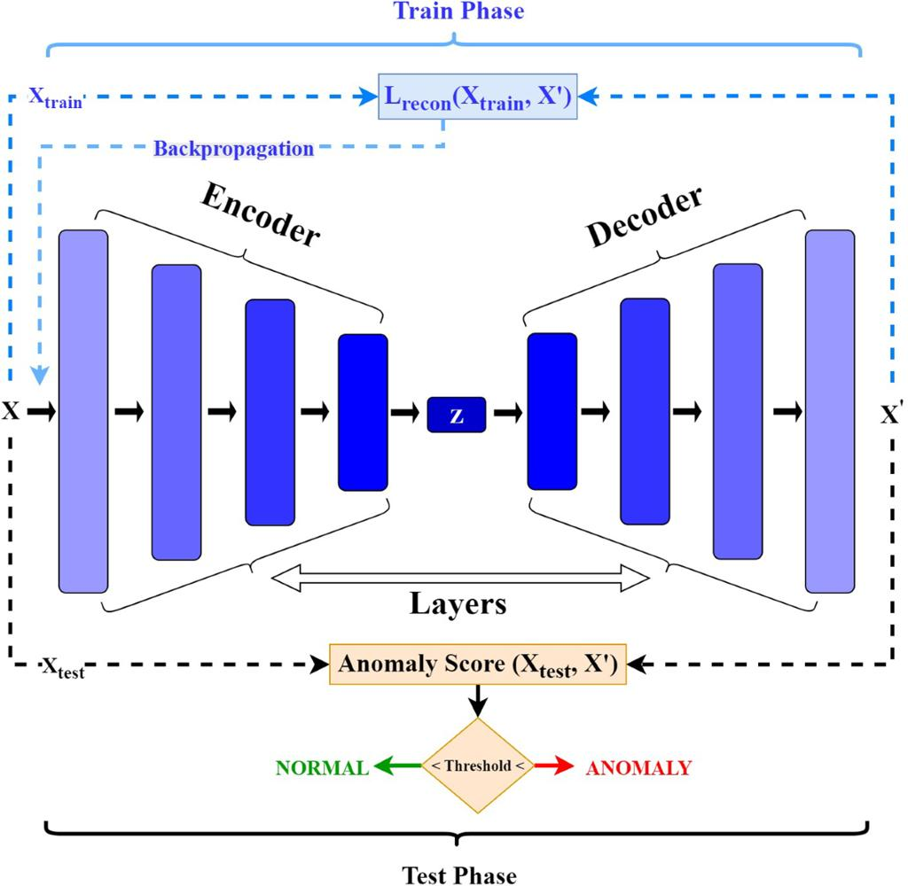

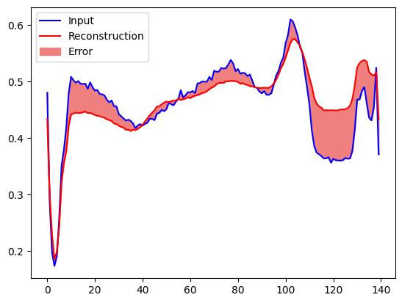

4
Place this image immediately after the paragraph explaining the autoencoder.
Workflow
- Collect thousands of ECG records.
- Preprocess and normalize the ECG signals.
- Feed the signals into the encoder.
- Encoder compresses the ECG into a latent representation.
- Decoder reconstructs the ECG.
- Calculate reconstruction error.
- Compare the error with a predefined threshold.
- Flag records with high reconstruction error for further examination.
ECG Reconstruction Error
ECG Record | Reconstruction Error | Prediction
ECG 1 | 0.02 | Normal
ECG 2 | 0.03 | Normal
ECG 3 | 0.04 | Normal
ECG 4 | 0.85 | Abnormal
ECG 5 | 0.92 | Abnormal


Figure 2: ECG Reconstruction Error and Normal/Abnormal Classification
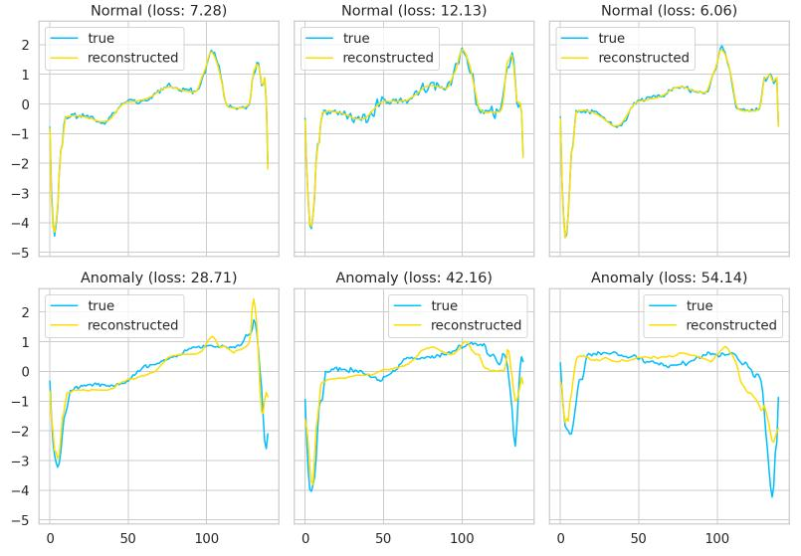

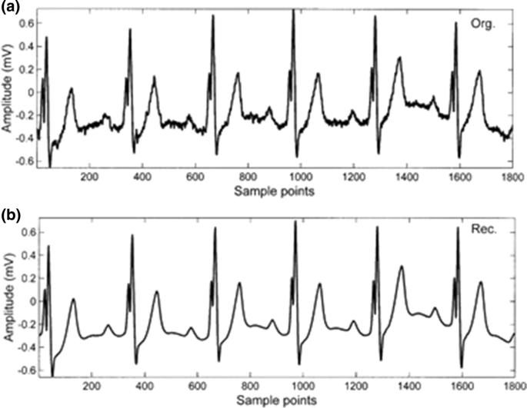

5
Conclusion
Therefore, an autoencoder is suitable because it can learn ECG representations without requiring labeled data. High reconstruction error indicates that an ECG pattern differs significantly from the patterns learned by the model.

Auto Encoders, Representation Learning
A retail company wants to reduce the dimensionality of customer purchase data before performing customer segmentation. Explain how an autoencoder can be used to solve this problem.
Answer
A retail company may have hundreds of customer purchase features. Directly using all features for clustering can increase computational complexity and may contain redundant information.
An autoencoder can reduce the dimensionality while preserving important information.
For example:
Figure 3: Autoencoder Architecture for Customer Data Dimensionality Reduction
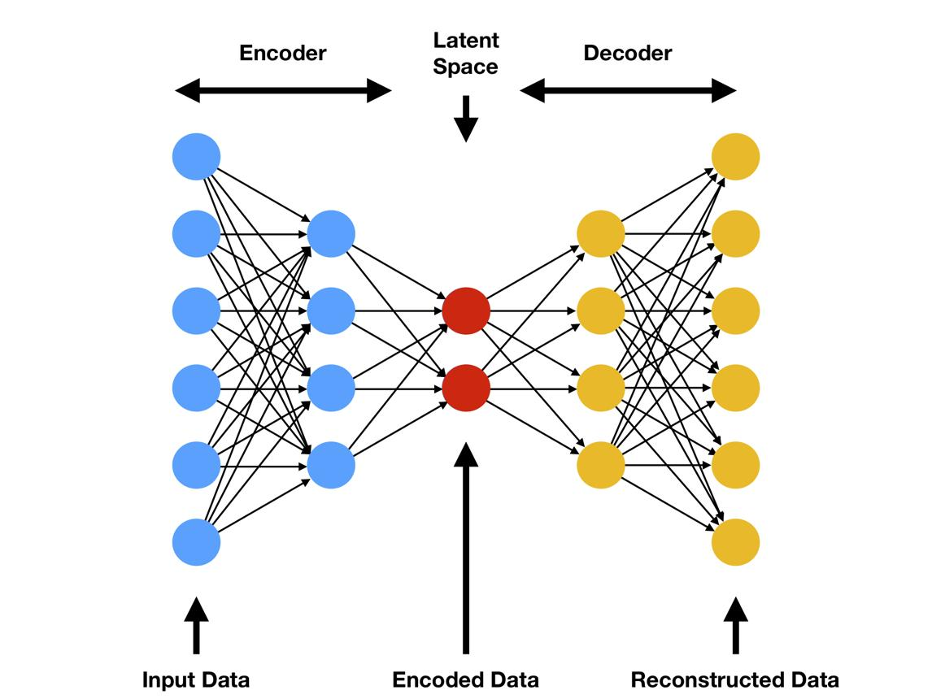
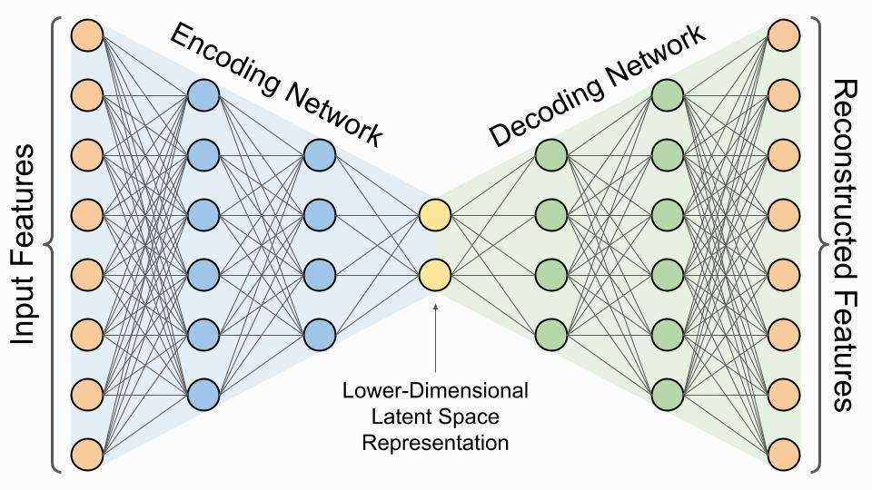
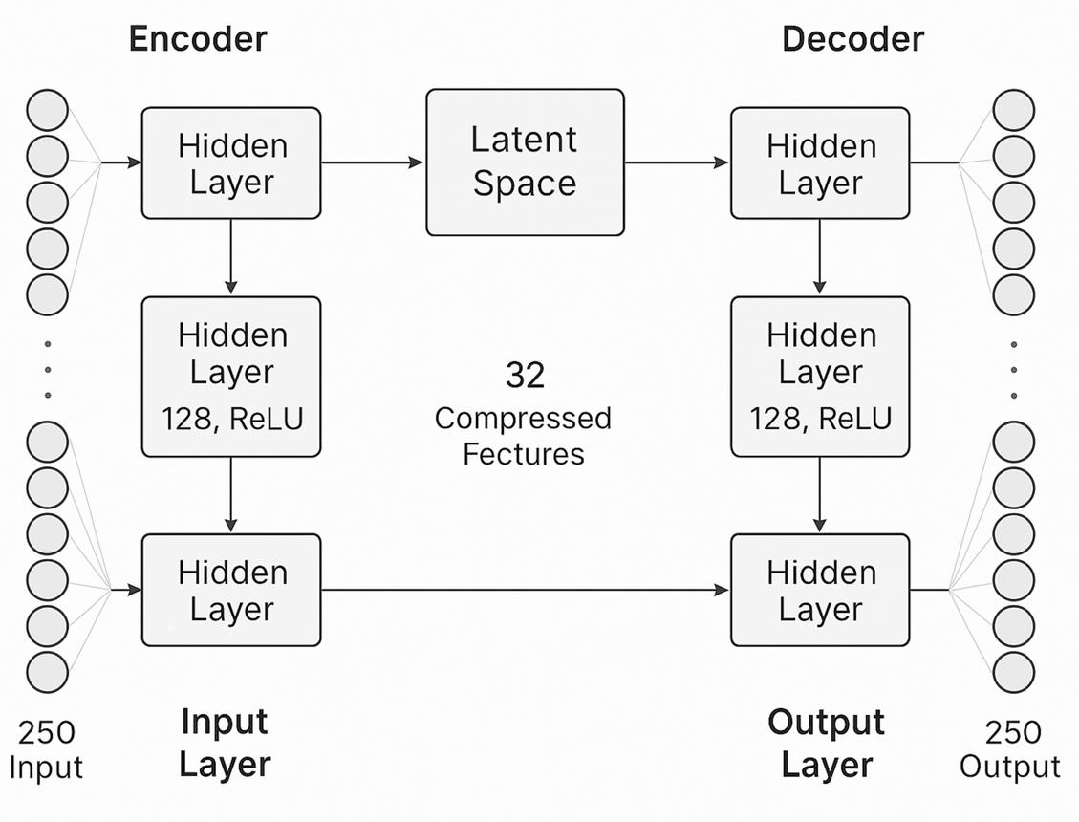

4
Place this image immediately after the 100 → 10 feature explanation.
Workflow
Customer Purchase Data
↓
Data Cleaning
↓
Normalization
↓
Encoder
↓
Latent Representation
↓
Clustering
↓
Customer Segments
Customer Segmentation Example
Segment | Characteristics
Segment 1 | High-value customers
Segment 2 | Discount-oriented customers
Segment 3 | Frequent shoppers
Segment 4 | Occasional shoppers
Segment 5 | Electronics-focused customers
Conclusion
The autoencoder's encoder produces a compact representation that can be supplied to K-Means or another clustering algorithm.

Width and Depth of Neural Networks, Activation Functions
A facial recognition system performs poorly when trained using a shallow neural network. Recommend architectural changes involving network depth and activation functions.
Answer
A shallow neural network may not have sufficient capacity to learn the complex hierarchical features required for facial recognition.
A deeper network can learn features progressively:
Face Image
↓
Edges
↓
Shapes
↓
Eyes / Nose / Mouth
↓
Facial Structure
↓
Person Identity
Figure 4: Hierarchical Feature Learning in a Deep Neural Network
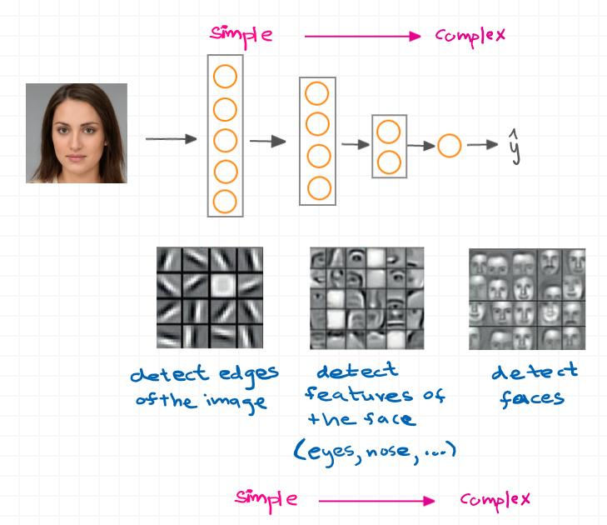

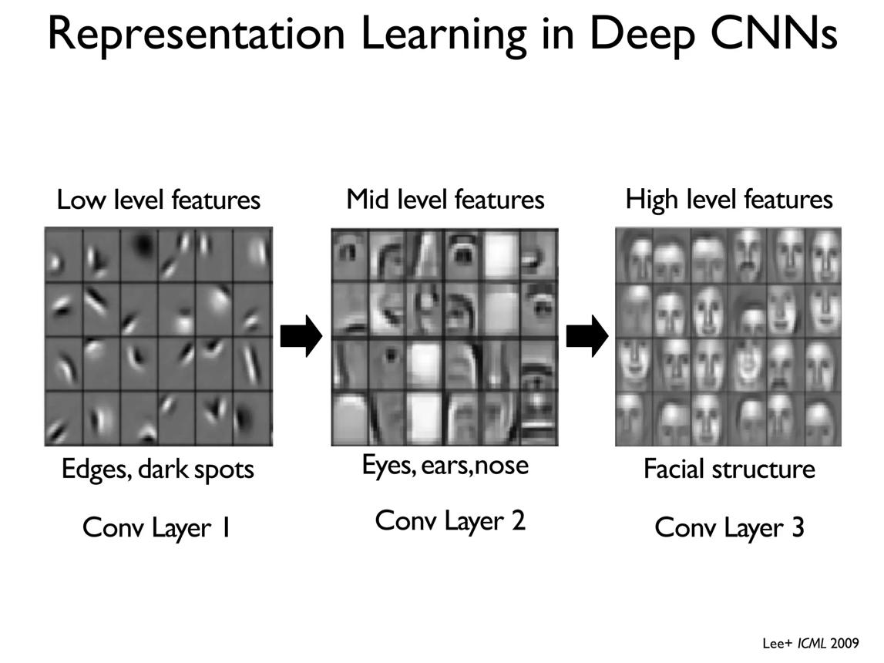
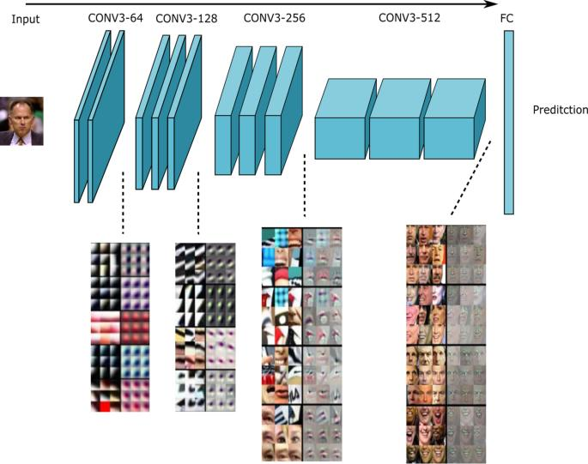

4
Place this image immediately after the feature hierarchy.
Recommended Architecture
Input Face Image
↓
Feature Extraction
↓
Hidden Layer 1
↓
Hidden Layer 2
↓
Hidden Layer 3
↓
Hidden Layer 4
↓
Fully Connected Layer
↓
Face Representation
↓
Classification
Activation Functions
ReLU
Leaky ReLU
Allows a small gradient for negative inputs and helps reduce the dying-ReLU problem.
ELU
Provides smooth negative outputs and can improve optimization in some networks.
Comparison
Activation | Main Advantage
ReLU | Simple and computationally efficient
Leaky ReLU | Reduces dying ReLU problem
ELU | Smooth negative region
Conclusion
The facial recognition system should use increased depth, suitable width, and nonlinear activation functions such as ReLU or Leaky ReLU.

Restricted Boltzmann Machines (RBMs), Unsupervised Training of Neural Networks
A streaming service wants to recommend movies to users based on their viewing history without using labeled data. Explain how RBMs can be applied to build the recommendation engine.
Answer
A Restricted Boltzmann Machine (RBM) can learn hidden patterns in user movie preferences without requiring explicitly labeled training data.
The RBM consists mainly of:
- Visible layer
- Hidden layer
The visible layer represents movie interactions, while the hidden layer learns latent user preferences.
Figure 5: Restricted Boltzmann Machine for Movie Recommendation
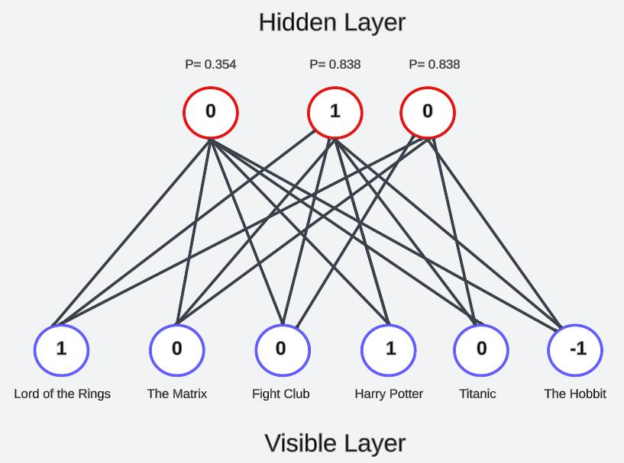

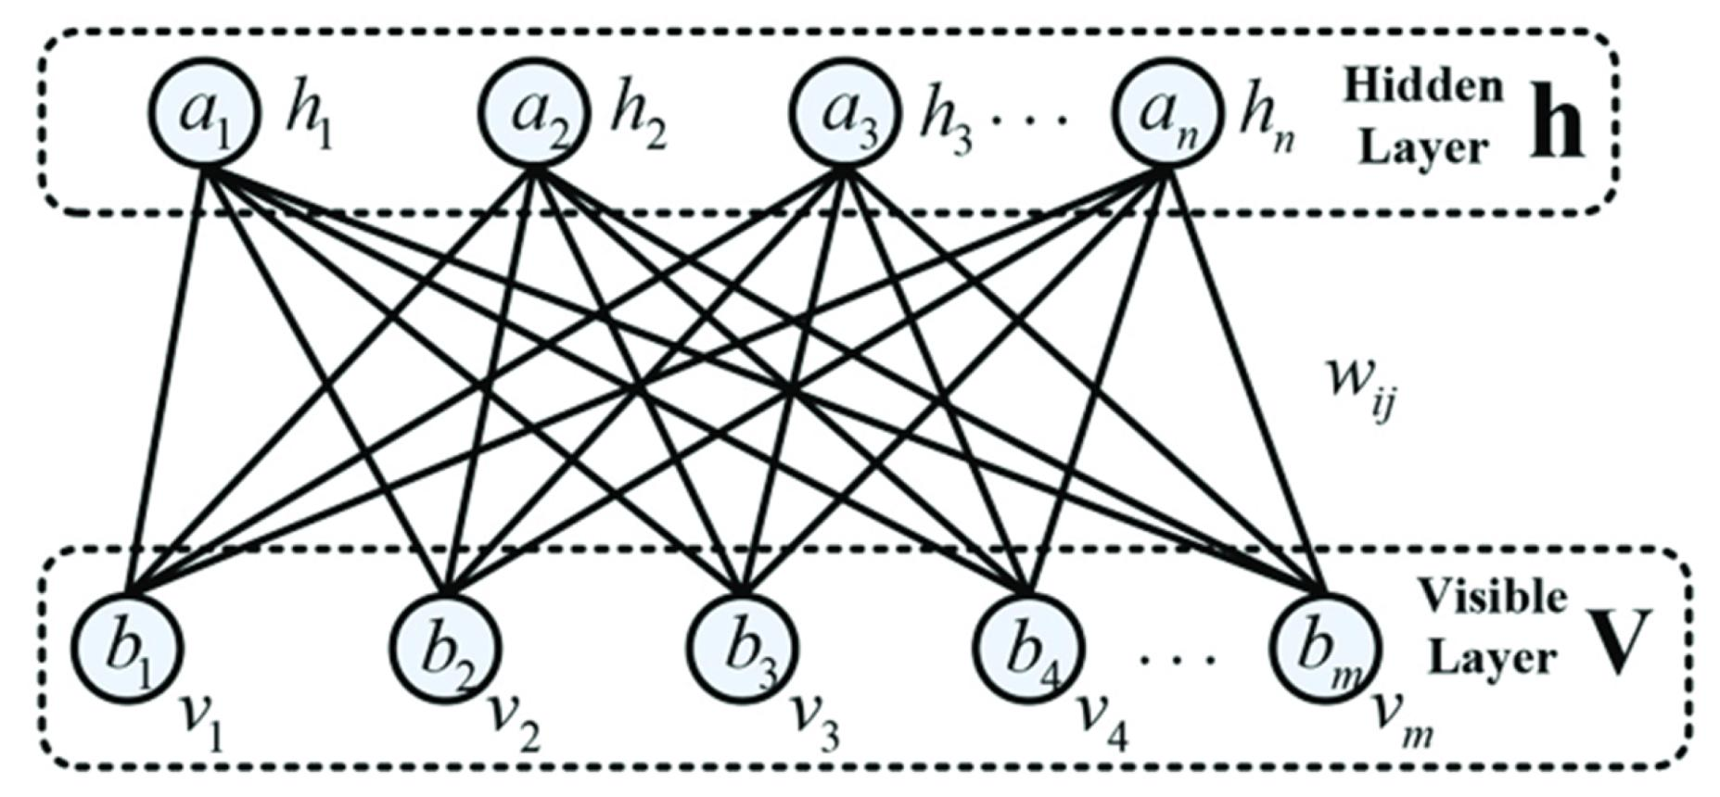
Place this image immediately after explaining the visible and hidden layers.
Workflow
User Viewing History
↓
User-Movie Matrix
↓
Visible Layer
↓
RBM
↓
Hidden Preferences
↓
Reconstruct Missing Preferences
↓
Rank Movies
↓
Top-N Recommendations
Example
User | Movie A | Movie B | Movie C | Movie D | Recommendation
U1 | 1 | 1 | 0 | 1 | Movie C
U2 | 0 | 1 | 1 | 0 | Movie A
U3 | 1 | 0 | 1 | 1 | Movie B
Here, 1 = watched/liked and 0 = not watched/unknown.
Conclusion
The RBM learns hidden preference patterns and uses them to predict missing movie preferences and generate personalized recommendations.

Deep Learning Applications, Representation Learning
A manufacturing company wants to detect defective products from sensor readings collected every second. Design a deep learning solution using concepts from representation learning and neural networks.
Answer
A manufacturing company can use a deep learning model to analyze sensor readings collected every second and classify products as normal or defective.
Possible sensor inputs include:
- Temperature
- Pressure
- Vibration
- Current
- Voltage
- Humidity
Figure 6: Deep Learning Workflow for Sensor-Based Defect Detection
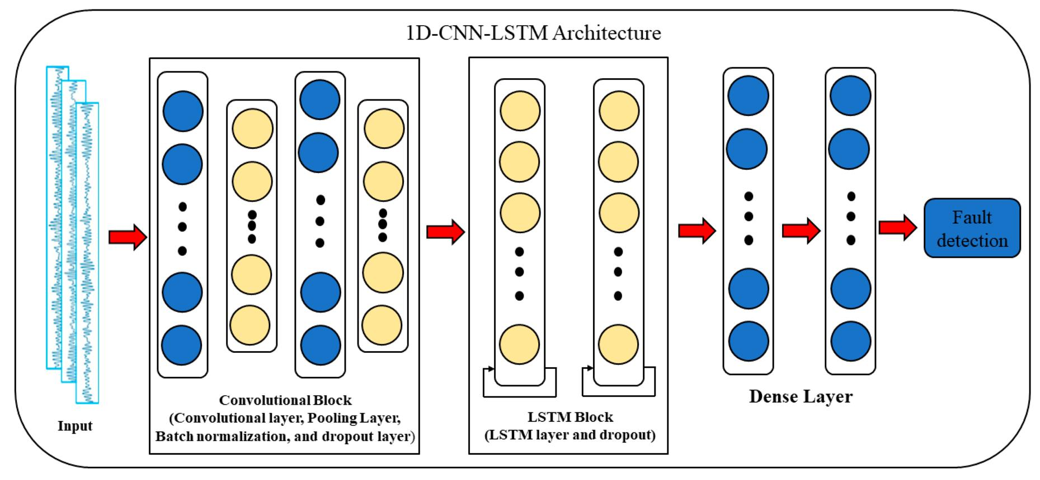
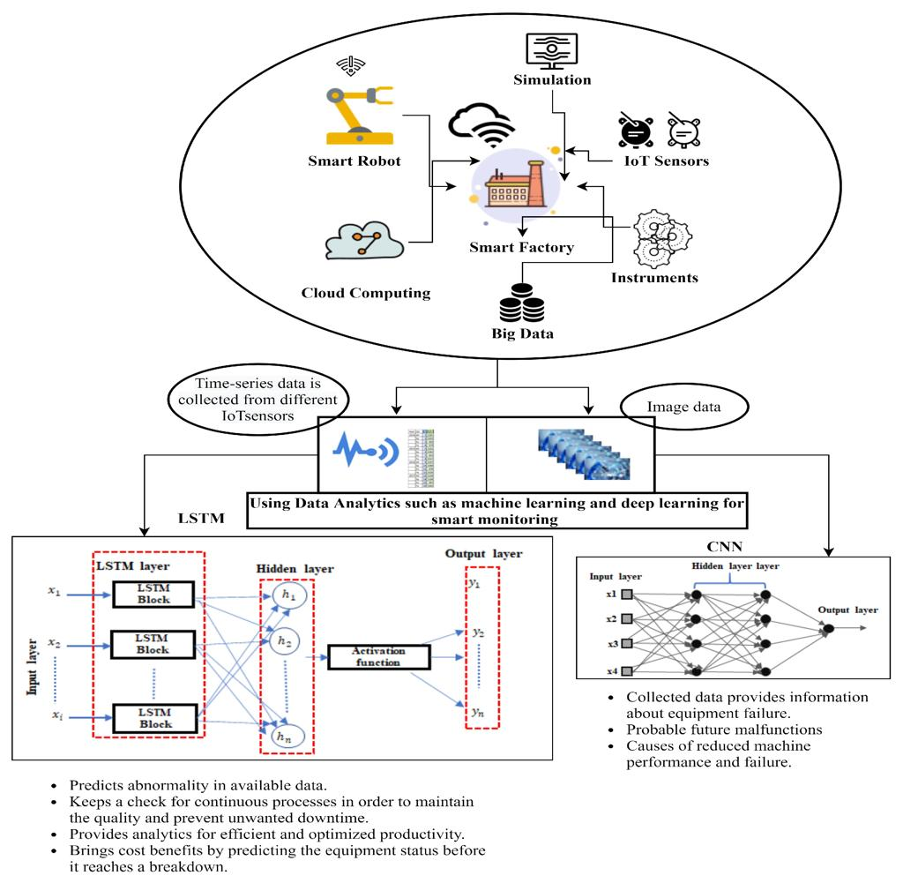
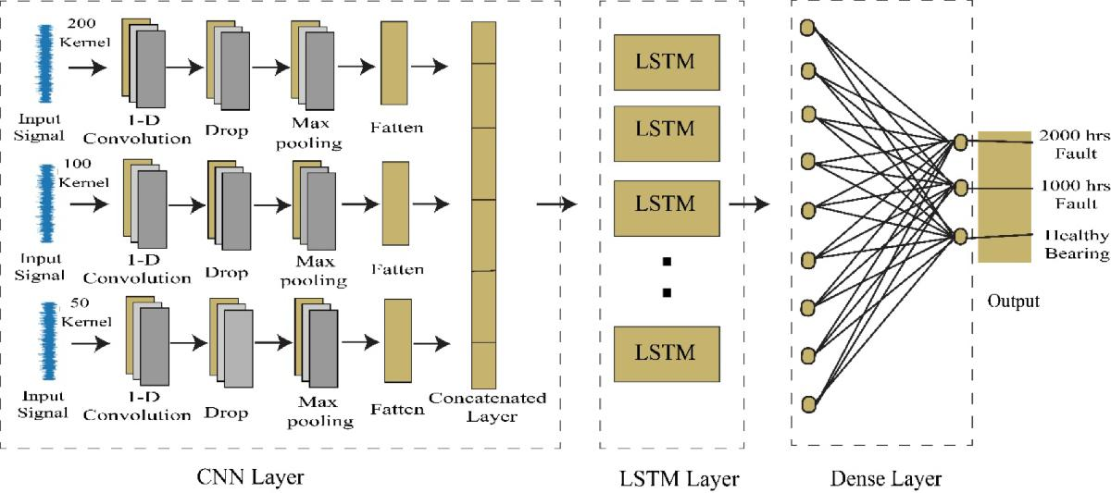
6
Place this image immediately after listing the sensor inputs.
Proposed Architecture
Sensor Data
↓
Preprocessing
↓
Time-Series Windows
↓
1D CNN / LSTM
↓
Representation Learning
↓
Dense Layer
↓
Defect Probability
↓
Normal / Defective

Sensor Data Example
Time | Temperature | Pressure | Vibration | Current | Defect Probability | Prediction
1 sec | 70.1 | 50.2 | 0.20 | 10.0 | 0.08 | Normal
2 sec | 70.5 | 50.4 | 0.21 | 10.1 | 0.12 | Normal
3 sec | 71.0 | 50.6 | 0.23 | 10.2 | 0.15 | Normal
4 sec | 72.0 | 51.8 | 0.85 | 11.2 | 0.91 | Defective
5 sec | 72.5 | 52.0 | 0.92 | 11.5 | 0.87 | Defective
6 sec | 71.5 | 50.7 | 0.25 | 10.3 | 0.18 | Normal

Figure 7: Sensor Readings and Defect Prediction
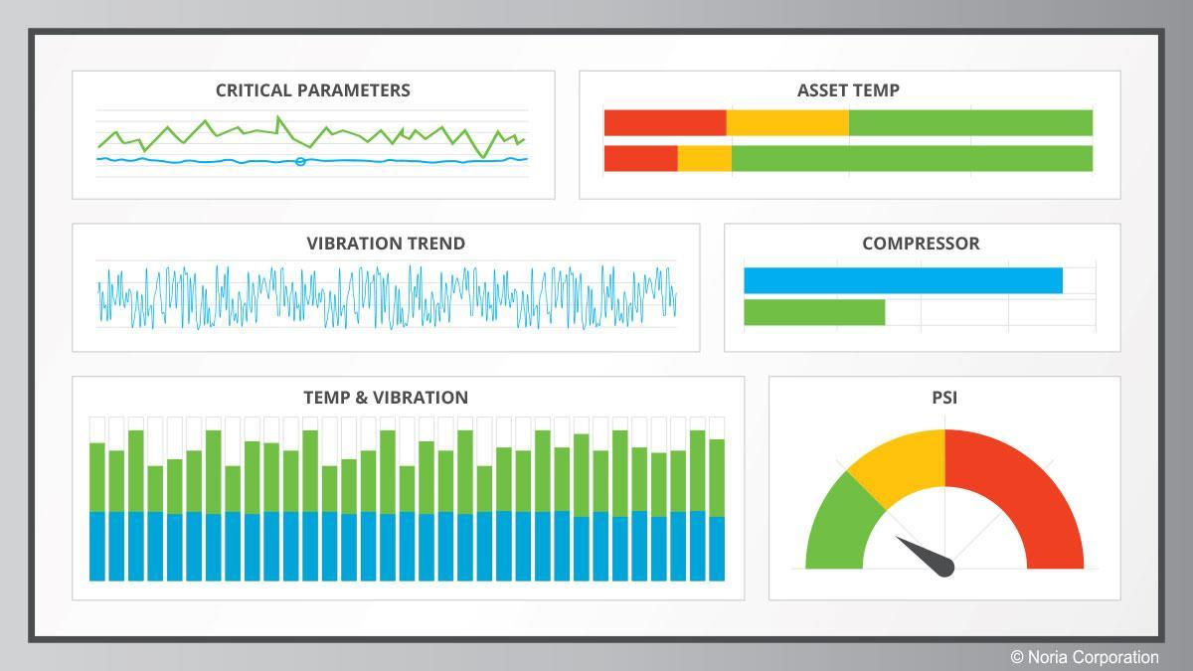
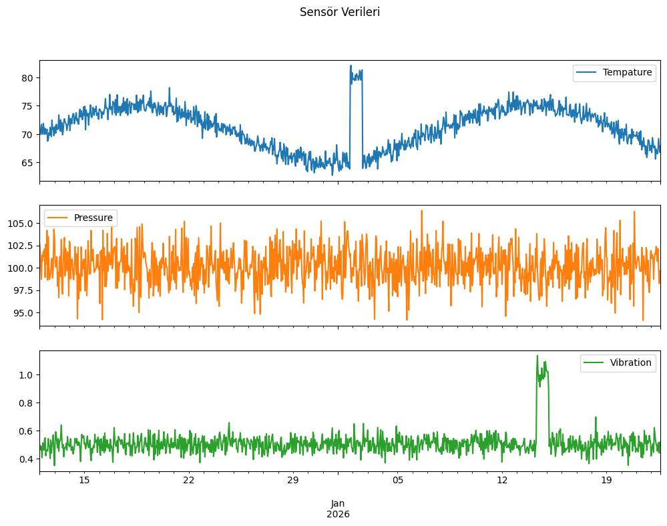
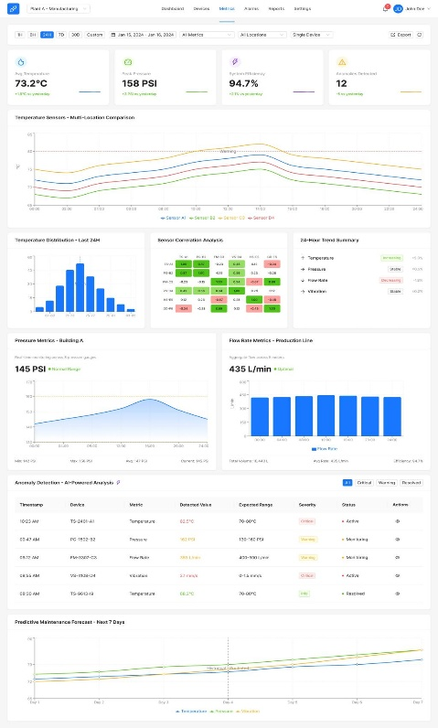

7
Place this image immediately after the sensor-data table.
Model Selection
Model | Main Strength | Suitable Application
1D CNN | Local feature extraction | Sensor signals
LSTM | Temporal dependencies | Time-series
CNN-LSTM | Local + temporal features | Complex sensor data
Autoencoder | Anomaly detection | Unknown defects
Conclusion
A CNN-LSTM model can learn both local patterns and temporal dependencies in sensor readings. The learned representation can then be used to predict whether a product is defective.

RUBRICS FOR CALCULATION:
Criteria | Weightage | Level 4 –  Exemplary | Level 3 –  Proficient | Level 2 –  Developing | Level 1 –  Beginning
Concept  Identification | 25% | Identifies all key concepts from literature accurately and comprehensively | Identifies most key concepts with minor omissions | Identifies limited concepts; some are irrelevant or missing | Fails to identify essential concepts

Linkages | 25% | Establishes clear, meaningful, and accurate relationships between concepts | Shows correct relationships with minor gaps | Relationships are weak, unclear, or partially incorrect | No meaningful relationships established
Organization | 20% | Concepts are wellstructured hierarchically with logical flow and grouping | Mostly organized with minor structural issues | Some  organization but lacks clear hierarchy | No logical organization or structure
Integration of  Literature | 20% | Integrates multiple studies effectively to show connections and comparisons | Shows some  integration of literature | Limited integration; mostly isolated concepts | No  integration of literature evidence
Clarity | 10% | Concept map is clear, neat, visually structured, and easy to interpret | Generally clear with minor readability issues | Clarity is reduced; difficult to interpret in parts | Poorly presented and hard to understand

